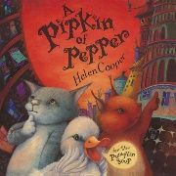
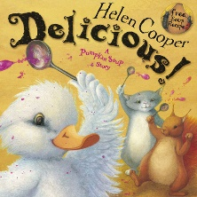
Foundation Term 1: Getting to Know You
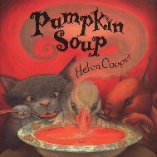
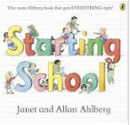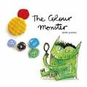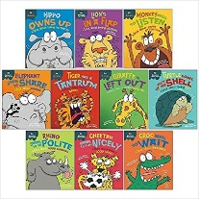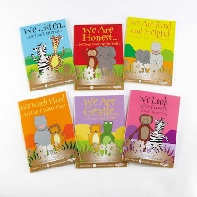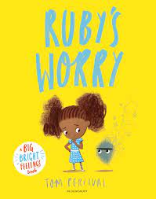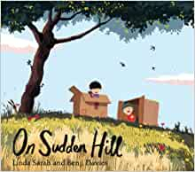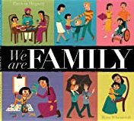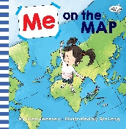
As Communicators:  Listening, Attention and Understanding:  Listen to others 1:1, in small groups and whole class.  Enjoy listening to stories and remember what happens.  Listen carefully to rhymes and songs, paying attention to how they sound.  Know how to listen carefully and why listening is important.  Listen to new vocabulary and start to use new vocabulary in context.  Maintain attention in whole class and small group contexts for a short time.  Starting to pay attention to more than one thing at a time.  Know how to follow 1 step instructions e.g., put your book bag in the tub.  Speaking and Responding:  Use sentences of 4-6 words.  Know a repertoire of songs e.g., nursery rhymes or numbers of songs.  Know some social phrases e.g., ‘Good Morning!  Talk in front of a small group and engage in group times.  Join in with repeated refrains and anticipate key events and phases in stories or rhymes.  Start to use new vocabulary through the day in discussions and conversations.  Use talk to organise themselves and their play.  Know how to respond appropriately in different situations. | As Citizens:  Expressing our feelings and Managing our behaviour:  Know that all feelings are ok. Know how to recognise own feelings, talk about feelings using words like ‘happy’, ‘sad’, ‘angry’. Begin to understand how others might be feeling.  Know they can rely on their teachers, friends, and ‘buddy’ for support  Can regulate own actions, welcomes support and distractions when upset.  Know the behavioural expectations of Foundation Class and the wider school.  Know the class rules and why following rules is important.  Know how to respect and take care of school resources.  Know what they like and do not like. Talk about the special things in their own lives.  Know how to organise themselves independently at school e.g., bookbag in tub, coat on peg, water bottle on trolley, name card on board.  Building relationships:  Know how to engage in positive interactions with adults and peers.  Play with one or more children, extending and elaborating play ideas.  Know that we can work together to keep the class rules and earn positive rewards.  JIGSAW lessons – Being Me in My World:  Covering self-identity, understanding feelings, being in a classroom, being gentle,  rights and responsibilities.
As Mathematicians:  Counting objects, actions and sounds – cardinality, 1:1 correspondence, accuracy, sequence and stopping number. Counting songs, action rhymes, using fingers to represent numbers.  Perceptual Subitising – within 5, structured and unstructured, composition.  Matching and Sorting into groups - same/different, sorting by colour, size, shape.  Comparing amounts – equal, more than, fewer than.  Comparing size, mass & capacity – big/little, large/small, short/tall, tallest/shortest.  Exploring pattern - making simple patterns, odd one out, exploring more complex patterns.  Identify 2D shapes – in the environment, composition with shape.  Positional language - ‘in’, ‘on’, ‘under’, ‘up’,‘down’, ‘next to’, ‘through, ‘between’.  Time - vocabulary relating to daily routines: ‘now’, ‘next’, ‘later’, ‘after’, ‘morning’, ‘lunch’, ‘afternoon’, ‘home time’, ‘today’, ‘tomorrow’, ‘yesterday’. | Being Physically Active:  Know the routines of the school day: lining up and queuing, mealtimes, personal hygiene, carpet spots, independently fastening coats and shoes, organising belongings.  Develop their small motor skills so that they can use a range of tools competently, safely, and confidently. Suggested tools: pencils for drawing and writing, paintbrushes, scissors, knives, forks, and spoon.  Continue to develop the overall body strength, co-ordination, balance, and agility needed to engage successfully with future physical education sessions. Focus on core strength,  PE lessons will focus on knowing how to follow instructions, and practise safe, independent work. Activities will involve listening, turn taking, negotiating space and controlling body movements. Our PE day is Wednesday.
As Readers:  Comprehension  Listen and enjoy sharing a range of books.  Know to handle books with care and how to hold a book correctly; the right way up and how to turn some pages appropriately.  Know that a book has a beginning, and an end.  Know that text in English is read top to bottom and left to right.  Know the difference between text and illustrations.  Know that illustrations help to understand what is happening in a story.  Know how to recognise some familiar words in print, e.g., own name or advertising logos.  Know familiar rhymes, stories or poems and complete a repeated refrain.  Enjoy joining in with rhyme, songs, and poems.  Word reading  Re-read books together with an adult to build up their confidence in word reading, their fluency and their understanding and enjoyment.  Read books independently that are consistent with their phonic knowledge.  Hear general sound discrimination and be able to orally blend and segment. | As Writers:  Emergent writing:  Know that writing communicates meaning.  Know that marks can have meaning.  Know how to write their name by copying it from a name card or try to write it from memory.  Composition:  Know that ideas for stories can be written down.  Use talk to link ideas, clarify thinking and feelings.  Spelling:  Know how to orally segment sounds in simple words.  Know how to write their name copying it from a name card or try to write it from memory.  Handwriting:  Know that print carries meaning and in English, is read from left to right and top to bottom.  Know how to draw lines and circles.
As Historians:  Know words to describe basic time and chronology – today, yesterday, last week, tomorrow, next week, morning, afternoon, season.  Know the members of their immediate family and the relationship to them, name and describe people who are familiar to them.  Talk about special events in their own lives. | As Geographers:  Know that families in other countries across the world engage in similar activities to their own family. Know some differences.  Mapping: Know that features of their immediate environment can be represented with objects, digitally and on paper e.g., classroom maps, seating maps, nature area map.  Know common signs and logos.
As Ecologists:  Know how to show respect and care for the natural environment and all living things.  Know that the environment where they live can change through the seasons. Describe what they see, hear, and feel outside.  Explore the natural world around them by taking part in Outdoor Learning activities. | As Scientists:  Ask questions about the world around them.  Know that you can find out information from different sources e.g., internet, books.
As Musicians:  Body percussion  Creating musical instruments  Charanga Songs: Pat-a-cake - 1, 2, 3, 4, 5, Once I Caught a Fish Alive - This Old Man - Five Little Ducks -Name Song - Things For Fingers | As Artists:  Explore, use, and refine a variety of artistic effects to express their ideas and feelings.  Look closely at self and choose colours and tools to create a realistic self-portrait.  Know how to grip a pencil comfortably and make marks, create lines and circles. Know that marks can have meaning.  Know the names of primary and secondary colours. Know how to create secondary colours.  Artist study – Yayoi Kusama
As Designers:  Know that materials can feel different. Know some words to describe materials.  Know joining techniques for joining materials together.  Know how to safely carry and pass scissors to another person.  Know how to use scissors to make snips in paper and cut materials. | As Actors:  Take part in simple, pretend play often based on familiar experiences, e.g., making dinner.  Uses available resources to create props or creates imaginary ones to support play.  Develop storylines through small-world or role-play

Curriculum Drivers: | Curiosity: | Knowledge of the wider world: | Aspirations:
 | What do we do at school?  Where do I live?  Is everyone the same as me?  How am I feeling?  Why are some materials better for tasks than others? | Where Stockham School is.  What School life looks like.  How other people might be feeling.  Investigating seasonal changes in our immediate environment | Understand the routines of school life and the rules that keep us all safe and help us to learn.  Navigate the school environment.  Take part in whole school events and understand my responsibilities in the school community.  Develop skills to manage school day: organising myself, managing hygiene needs, lining up, lunchtimes, listening skills, taking turns, recognising emotions.
Vocabulary | Tier 1: head, shoulders, knees, toes, eyes, ears, mouth, nose, hands, feet, thumb, finger, please, thank you, circle, on, off, in, [months of the year], now, next, first, then, after, [language of resources], [names of emotions], join, stick, cut, pretend, tap, clap, pat, shape, brush, {names of colours], see, hear, feel, smell, map, [names of relatives], name, surname,  Tier 2— similar, different, respect, tolerance, diversity, unique, responsibility, respect, perseverance, independence, resilience, self-portrait, primary and secondary colour, rhythm, pulse, environment, season, past, collaborative
Whole School Value of the term | Curiosity

Home learning & Support: | Reading - please share stories together at least 3 times per week, daily if possible. These can be stories that you read aloud to your child at this point, e.g. a bedtime story. Talk about the stories that you read and encourage children to join in with repeated refrains and rhymes in the books. Please record in child’s Reading Diary.  Weekly Home Learning Challenge – linked to our weeks learning. This will be sent home weekly each Tuesday, and will be due in the following Monday. Homework in Foundation is optional, but encouraged. We have designed these tasks to enable your home discussions to give your child a head start of the topics and curriculum we will be covering in class. This can make children more confident to speak about and join in with the tasks in school, which in turn means they will gain more from the learning tasks.

