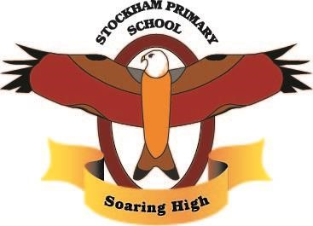
Issue Date: | April 2023
Reviewed by: | Joanne Wilkinson
Date of the last Review: | 3 March 2023
Next Review Date: | 3 March 2025

Stockham Primary School Phonics Policy. 2023

Version History

Version | Date | Description of Changes -
1.0 | April 2023 | Issuance of the policy

Teaching children to read is an essential part of their learning. Reading is a skill that helps to develop vocabulary and improve understanding of words. In synthetic phonics lessons, children learn the relationship between letters and sounds. Teaching them to recognise the sounds each letter makes and how to put them together, enables them to read. It also helps with spelling as they learn how to break up words into sounds, in order to spell them. The idea that surrounds synthetic phonics is that once they are comfortable with the letters and sounds that make up words, children should even be able to read ‘nonsense’ words that don’t actually exist in the English language.

Our Aims:

• To establish a cohesive whole-school approach with progression and continuity in the teaching and learning of phonics throughout the school with a focus on quality first teaching.
• To ensure that systematic synthetic phonics (following the Twinkl Phonics programme) is the first approach pupils use to help with their reading and spelling.
• To ensure children learn to read and write all 44 graphemes in the English language.
• To ensure children have specific strategies to identify and decode common exception words (tricky words).
• To have robust assessment procedures to check progress and identify pupils in need of intervention.
• For pupils to apply their phonic knowledge in their reading and writing across the whole curriculum.
• For pupils to develop a love of reading and enjoy reading for pleasure confidently across a range of genres.

Objectives:

• To provide consistent, high-quality phonics teaching that ensures all children have a strong foundation upon which to tackle the complex processes of reading and writing.
• To ensure that the teaching of synthetic phonics is systematic and progressive throughout the foundation stage, key stage one and key stage two for those children needing interventions to support phonetic knowledge and understanding.
• To ensure that children have strong phonetic knowledge, understanding and skills so that they can decode words confidently and engage with higher-order reading and writing skills

What Is Phonics?

Phonics is a way of teaching children how to read and write. It helps children hear, identify and use different sounds that distinguish one word from another in the English language. The Department of Education establishes the core criteria for effective systematic synthetic phonics teaching programmes. Using phonics programmes, children are taught to read and write using phonics, which is by directly linking phonemes (sounds in words) and graphemes (the symbols used to represent them).
In the UK, phonics for children is an important feature of the curriculum. Children learn phonics through a curriculum scheme such as Twinkl Phonics. Phonics is considered the best way to teach children to read.

How We Deliver Our Phonics Teaching

We use Twinkl Phonics as our systematic, synthetic phonics programme (SSP). It is high quality and robust in its purpose. With a clear, structured progression through the programme, it allows all of our pupils to meet or exceed the expected standard.
The Twinkl Phonics approach combines rigorous progression with engaging learning materials. We believe that children learn best when they are enjoying their learning and that this comes from a mix of bright, fun and engaging lesson resources within a clear and systematic approach that builds on children’s skills daily.
The structure of every Twinkl Phonics lesson follows this familiar five-part structure to ensure that the four cornerstones of phonics are covered. During our phonics lessons, children will repeat the elements from the four cornerstones of phonics to ensure that they have rapid and automatic recall of GPCs and tricky/common exception words; each day, they will experience blending and segmenting activities to allow regular practice of these core skills.
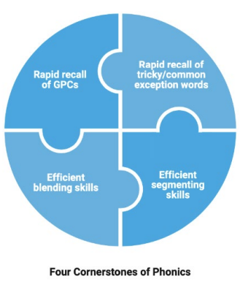

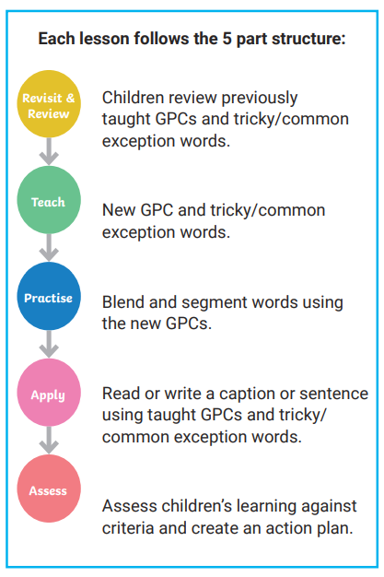

Stories are used to provide a stimulus and context for phonics teaching in our Twinkl Phonics lessons. The story content also integrates games to practise the skills taught. Our phonics lessons are also supported by weekly decodable minibooks, which are part of our core provision, where children can apply the skills they have learnt in their phonics lessons. As part of our wider SSP provision, there are also follow-up activities that the children can complete independently, in pairs or in groups that relate to the day’s learning.
In addition, we use actions to help the children remember phonemes; this kinaesthetic, visual and auditory approach helps the children to retain the phonemes and supports children with SEND. Decodable reading books are also provided, matched to the children’s phonic level through the use of Rhino Readers, Songbirds (Oxford Reading tree), Bug club, Floppy Phonics (sounds and letters) and Big Cat phonics. We use both individual and guided reading to teach reading alongside phonics. We also use a mix of eBooks and physical books.
In conjunction with the teaching of phonics, we also give our children phonics-based activities to take home at the appropriate level. These include parent information sheets and home learning booklets. This helps to consolidate what has been taught in school and encourages a cohesive whole-school approach.

Timetabling/Structure

Phonics is taught daily to all children in EYFS and key stage 1. Within reception, phonics sessions will increase in length over the year. By the end of reception, children spend about an hour a day consolidating previous learning, learning new content and practising and applying what they have learnt. This will consist of a mixture of carpet time and follow-up activities.
In year 1 and 2, phonics lessons will last about an hour each day. Some children may continue to need discrete phonics sessions in key stage 2. If this is the case, they will receive a daily 20 minute intervention session, delivered using the Twinkl Phonics Codebreakers interventions.
Children will be regularly assessed to ensure they are receiving phonics teaching at the correct level.

Progression

Foundation:

The purpose of Level 2 is to:
• teach the first 19 most commonly-used letters and the sounds they make;
• move children on from oral blending and segmenting to blending and segmenting with letters;
• introduce some tricky words for reading.
Before starting this Level, children:
• will have had an experience of a wide range of listening activities including songs, stories and rhymes;
• can distinguish between different sounds, including speech sounds;
• may be able to orally blend and segment words;
• may be able to identify some rhyming words.
By the end of Level 2, children will have had opportunities to:
• identify the phoneme when shown any Level 2 grapheme;
• identify any Level 2 grapheme when they hear the phoneme;
• orally blend and segment CVC words;
• blend sounds to read VC words, such as, ‘if’, ‘am’, ‘on’ and ‘up’;
• segment VC words into their sounds to spell them (using magnetic letters);
• read the tricky words: the, to, I, no, go.

The purpose of Level 3 is to:
• introduce another 25 graphemes, including consonant digraphs, vowel digraphs and trigraphs so that children can represent 42 phonemes with a grapheme;
• continue to practise CVC blending and segmentation;
• apply their knowledge of blending and segmenting to reading and spelling simple two-syllable words and captions.
Before starting this Level, children:
• recognise Level 2 GPCs;
• orally blend and segment CVC words as well as being able to blend and segment to read and spell CVC words and nonsense words;
• read the tricky words - the, to, I, no, go.
By the end of Level 3, children will have had opportunities to:
• say the phoneme when shown all or most Level 2 and Level 3 graphemes;
• find all or most Level 2 and Level 3 graphemes, from a display, when given the phoneme;
• blend and read CVC words (single-syllable words consisting of Level 2 and Level 3 graphemes);
• segment and make a phonetically plausible attempt at spelling CVC words (single-syllable words consisting of Level 2 and Level 3 graphemes);
• read the tricky words - he, she, we, me, be, was, my, you, here, they, all, are & spell the tricky words - the, to, I, no, go;
• write each letter correctly when following a model
The purpose of Level 4 is to:
• consolidate children’s knowledge of graphemes in reading and spelling words, especially digraphs and trigraphs;
• introduce words with adjacent consonants - CVCC, CCVC, CCVCC, CCCVC, CVCCC, CCCVCC, CCVCCC;
• learn polysyllabic words and learn to read and spell some more tricky words.
Before starting this Level, children:
• recognise Level 2 and 3 GPCs;
• blend and read CVC words;
• segment and make a phonetically plausible attempt at spelling single-syllable CVC words; • read the tricky words - he, she, we, me, be, was, my, you, here, they, all, are & spell the tricky words - the, to, I, no, go
By the end of Level 4, children will have had opportunities to:
• give the phoneme when shown any Level 2 or Level 3 grapheme;
• find any Level 2 or Level 3 grapheme when given the phoneme;
• blend and read words containing adjacent consonants as well as segment and spell words containing adjacent consonants;
• read the tricky words - some, one, said, come, do, so, were, when, have, there, out, like, little, what & spell the tricky words - he, she, we, me, be, was, my, you, here, they, all, are;
• write each letter, usually using the correct formation; • orally segment words into phonemes.

Year 1:

The purpose of Level 5 is to:
• learn alternative graphemes for known phonemes;
• learn alternative pronunciations of known graphemes; • introduce split digraphs;
• introduce suffixes and prefixes;
• learn to read and spell more common exception words.
Before starting this Level, children:
• recognise Level 2 and 3 GPCs;
• blend to read and segment to spell words containing adjacent consonants;
• read tricky words - some, one, said, come, do, so, were, when, have, there, out, like, little, what;
• spell tricky words - he, she, we, me, be, was, my, you, here, they, all, are;
• write each letter, usually correctly.
By the end of Level 5, children will have had opportunities to:
• give the phoneme, when shown any grapheme that has been taught;
• for any given phoneme, write the common graphemes;
• apply phonics knowledge and skills as the primary approach to reading and spelling unfamiliar words that are not completely decodable;
• read and spell phonically decodable two-syllable and three-syllable words;
• read automatically all taught tricky and common exception words;
• accurately spell all the Level 2, 3 and 4 tricky words and most of the common exception words for reading;
• form each letter correctly; • use alternative ways of pronouncing and representing the long vowel phonemes.

Year 2:

The purpose of Level 6 is to:
• develop children’s knowledge of spelling patterns and best-guess grapheme selection;
• learn more alternative graphemes for known phonemes;
• learn more alternative pronunciations for known graphemes;
• introduce the /zh/ phoneme; • develop an understanding of the spelling rules for adding suffixes and prefixes;
• introduce homophones/near homophones and contractions;
• learn to spell more common exception words;
• develop their understanding of grammar rules;
• learn effective writing techniques including editing and proofreading and learn more strategies to read and write independently.
Before starting this Level, children:
• give the phoneme, when shown any grapheme that has been taught;
• for any given phoneme, write the common graphemes;
• apply phonics knowledge and skills, as the primary approach to reading and spelling unfamiliar words that are not completely decodable;
• read and spell phonically decodable two-syllable and three-syllable words;
• sight-read all taught tricky and common exception words;
• accurately spell all the Level 2, 3 and 4 tricky words and most of the common exception words for reading;
• form each letter correctly; • use alternative ways of pronouncing and representing the long vowel phonemes
By the end of Level 6, children will have had opportunities to:
• read accurately most words of two or more syllables; • read most words containing common suffixes;
• read most common exception words; • read most words accurately, in age-appropriate books, without overt sounding and blending, fluent enough to allow them to focus on their understanding rather than on decoding individual words;
• sound out most unfamiliar words accurately, without undue hesitation;
• segment spoken words into phonemes and represent these by graphemes, spelling many of these words correctly and making phonetically plausible attempts at others;
• spell most common exception words correctly. Children identified as not making the expected progress will be identified early and will receive additional phonics interventions either through same-day interventions or in small focus groups following an assessment
KS2

For those children who are working below age-related expectations, phonics learning should not end in KS1. If, through assessment and observation, teachers have decided that a child needs further phonics intervention, Twinkl Codebreakers will be used. It is a comprehensive and scripted intervention programme, specifically designed for KS2 pupils to close the gap and develop essential reading and writing skills. Consideration will also be given as to whether these children would be best supported through a Support Plan (see SEND Policy).

Assessment

Assessing in Foundation & KS1:

In foundation, year 1 and year 2, children should be assessed on their knowledge of GPCs and tricky/common exception words each half-term, to establish their phonic level. Blending and segmenting assessments should also be carried out to ensure that children have the skills securely in place for reading and spelling.

Inclusion/ Intervention

Supporting the Lowest 20% Achievers:

Regular assessment is vital to ensure the early identification of children who may need us to provide them with extra support, either through interventions or during daily classroom teaching. Ideally, these children will take part in daily, highly structured interventions, which will normally include recapping or relearning missing GPCs and tricky/common exception words and practising blending and segmenting skills. As soon as we identify any child who is struggling to succeed in phonics, the provision will be put into place to close the gap.

Extending and Challenging Fast Learners

Regular assessment is also vital to ensuring the early identification of children who may need us to challenge them further, either through extension activities or during daily classroom teaching.

Year 1 Phonics Screening Check

In the summer term, all children in year 1 will undertake the National Phonics Screening Check. This is an assessment carried out in school during which the children will be assessed on their ability to segment and blend a range of 40 real and ‘alien’ words. Alien words are a selection of phonetically decodable nonsense words. The words in this assessment gauge the children’s understanding of the phonemes learnt and give the school the knowledge of where the gaps are. If the children are not secure in recognising, segmenting and blending these words and therefore do not pass the assessment, they will be offered further support as they enter year 2 and will be able to repeat the assessment in the summer term of year 2. This assessment also allows us to put in specific and personal support for those children who require additional assistance. If a child does not meet the expected standard in year 2, then phonics teaching and learning will be continued into key stage 2. At this point, the child will also be monitored by the SENCo to assess for additional needs.

Home Learning Expectations

Parental involvement is key in the acquisition of phonics and supports us in developing a cohesive whole-school approach. A phonics workshop for foundation parents is held in the autumn term and there are two phonics workshops for year 1 and year 2 parents during the year. During these sessions, we will be sharing information on techniques, such as saying pure sounds and blending. We will also share support resources regularly, such as the parent information sheets, as these can help ensure that parents and carers are using the same strategies at home as the children are learning in school. Phonically decodable reading books are also sent home for parents to support their child’s phonics/reading.

Rhino Readers Decodable Books

Our decodable Rhino Readers reading books make sure children are well prepared to read, containing a ‘before reading’ page which allows children to rehearse the grapheme-phoneme correspondences and tricky/common exception words they will meet in the text. The sound cards match the Twinkl Phonics mats, providing familiarity, and there are also blending practice activities, containing focus words with sound buttons.
The ‘after reading’ activities are designed to encourage discussion, recall, sequencing, comprehension and inference at a level appropriate to the text. There are also ‘Rhino Challenges’, with ideas for linked artwork, discussion, drama, craft, investigation - there’s something for everyone to add to the experience and help children make links to their own experiences. Children will have access to these books using the twinkl home learning platform and as physical books sent home daily.

Policy Review

This policy was written by the phonics subject leader, Catherine Hughes
It was completed in December 2022. and will be reviewed on September 2023
Its implementation is seen as the responsibility of all staff. Its use and effectiveness will be supported and monitored by the phonics subject leader, on behalf of the head teacher and governors.

