Dear Parents and carers,
We are very much looking forward to welcoming all the children back to school next Thursday 3rd September. We are working hard to get everthing ready and safe for the children’s full return.
I have repeated some information that you will have seen before regarding start times, drop offs and items to bring to school –see below. I have also attached a letter from Kevin Gordan (Director of Children’s services).
We have a changed lunch menu for September: This menu is free for Foundation, year 1, Year 2 and children in KS2 who are entitled to free school lunches. Children order their lunch at the start of each school day. We are hoping to return to a full hot dinner menu in very soon!
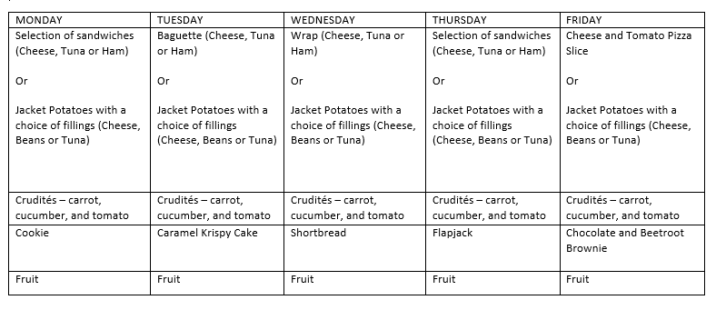
Drop off and pick up
There will be a one way system leading into the KS1 playground and a separate one way system for the KS2 playground. Entrance to KS1 playground will be past the garage (green arrows), through the KS1 playground, and then exit across the car park, following the blue arrows at all times. Entrance to the KS2 playground will be following the path past the scooter shed area (green arrows), in the KS2 playground and out through the car park, again following blue exit arrows. The main school gates will be closed to all vehicles after 8.30am. The car park is for staff only, please do not use the car park for breakfast club or Camel pre-school drop offs. We are asking that only one parent drops off or picks up. Please arrive for both drop off and pick up 2mins before the times stated below. When children arrive in the playground, we ask that they immediately line up outside their classroom with their teacher, rather than playing. The side gate will be closed whilst we operate this one way system.
Children may cycle or scooter to school as usual, but please can I ask that footballs and play equipment from home are not brought into school.
I know that for some children, returning to school after a long break away may cause some level of anxiety/stress. Staff will be available to support children coming into the school. Unfortunately, we are unable to invite parents into the school building due to health and safety guidelines. Parents should leave the school premises after drop off and pick up and avoid congregating at the school gate entrance.
If you need to contact the office, it is best to do this by phone or email. The office window (in the KS12 playground) will also be open for quick enquiries in the morning and at the end of the day.
Start and finish times
I have kept start and finish times as close to the original timings as possible. There are slight changes for Years 2,3 and 4 due to congestion in either shared coat peg areas or to reduce the number of people of the playground at any one time.
If you are doing multiple drop offs and collections, please can I ask that you still follow the one way systems when dropping off siblings. Please wait away from the lining up zones until it is your child’s class start time. When collecting your child/ren, please can I ask that parents stand back from the classroom door and socially distance from each other.
Breakfast club drop off is through the KS2 playground, round the building to the ‘Swamp’ classroom. Please follow the green arrows in and stick to the blue arrows on exit.
Foundation children have a few days with slightly different timings –please follow the dates on the new starters web page named June 2020, before your child starts full time on Wednesday 9th September. https://stockham.eschools.co.uk/web/new_starters
Year group | Start time | Finish time | Drop off and collection point
Foundation | 8.40am | 3.00pm | Drop off through KS1 playground, line up on 2D paint shapes, follow blue arrows for exit
Year 1 | 8.40am | 3.00pm | Drop off through KS1 playground, line up on the painted phonics and circles, follow blue arrows for exit
Year 2 | 8.50am | 3.10pm | Drop off through KS1 playground, line up on 2D paint shapes, follow blue arrows for exit
Year 3 | 8.50am | 3.10pm | Drop off through the KS2 playground, line up on the painted diamonds and circles, follow blue exit arrows
Year 4 | 8.50am | 3.10pm | Drop off through KS2 playground, line up on painted feet outside year 4, exit using blue arrows.
Year 5 | 8.40am | 3.00pm | Drop off through KS2 playground, line up on painted markers outside year 5, exit using blue arrows.
Year 6 | 8.40am | 3.00pm | Drop off through KS2 playground, line up on painted swirls and circles outside year 6, exit using blue arrows.

If your child feels confident about entering school, we would ask that you say goodbye to your child at the key stage gates. The class teacher will be there waiting for them to line up. If children are a little anxious or upset, then of course parents can support their entry in the playground.

Items to bring into school
We are asking that all children bring into school a named, wipeable, plastic pencil case. These can be found in places such as B and M, Sainsbury’s, stationary shops and online at amazon. Inside the pencil case should be:
- A pencil
- A small ruler
- A pencil sharpener
- A rubber
- A small glue stick
- A small selection of coloured pencils
Please ensure your child does not bring in any other equipment, especially fluffy pens and pencils! If you are unable to provide this pencil case, school will provide your child with one, or any of the content during the first few days back at school.
Children are expected to wear full, smart school uniform with sensible black footwear. Children should bring into school each day: a named water bottle, a wipeable lunch box –no fabric lunch boxes (if they are not having a school provided lunches), PE kit and outdoor trainers, indoor shoes and their school book-bag. Children may bring a rucksack to carry all of their items in.
If your child is unwell and is showing signs of Covid 19, please follow the isolation guidance. https://www.gov.uk/government/publications/covid-19-stay-at-home-guidance/stay-at-home-guidance-for-households-with-possible-coronavirus-covid-19-infection
A full risk assessment of our school can be found on our website: https://stockham.eschools.co.uk/web/risk_assessment_for_sept_2020/503326
We look forward to seeing you all on Thursday 3rd September. Please ensure that you only arrive 2 mins before your child’s start time.
Thank you
Mrs Ruth Burbank

