Theme:
Spring is Here!
Term 4
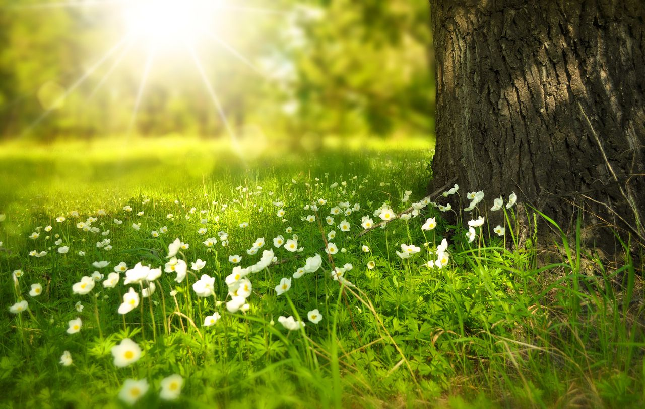

Breadth:

As writers:  Segment spoken words into phonemes, spelling many correctly.  Learn new ways of spelling phonemes for which one or more spelling can be used.  Poetry – Write a repetitive poem.  Narrative writing – use a variety of techniques to write narrative paragraph.  Instructional writing.  Proof reading to check for errors in spelling and punctuation. |  | Being physically active:  Focus: Gymnastics.  Create simple sequences using apparatus.  Vault/Flight  Focus: Net and Wall skills.  Our PE days are: Wednesdays and Thursdays. | As computer Experts:  Record data in a tally chart and represent totals.  Enter data into a computer.  Create a pictogram and explain what it shows.  Collect data.  Use a computer program to represent information in different ways. | As scientists:  Know the difference between seeds and bulbs  Experiment what plants need to grow  Describe what plants need to grow and stay healthy  Describe the lifecycles of a plant  Understand plants adapt to suit their environment  Observe and record the growth of plants over time.
As readers:  Apply phonic knowledge and skills as the route to decode words until automatic decoding has become embedded and reading is fluent.  Read accurately by blending the sounds in words.  Read accurately words of two or more syllables.  Listen to, discuss and express views about stories at a level beyond that at which they can read independently.  Discuss the sequence of events in stories.  Become increasingly familiar with retelling stories.  Answering and answering questions. |  | As Historians:  Museum Visit  Explore people from the past who are famous in the Vale for their passions and achievements.  Key figure: Jethro Tull and his role in the agricultural revolution  Explore farming implements from the past and identify their uses. | Religious Education:  How important is it to Christians that Jesus came back to life after his crucifixion?  Re-tell the Easter story and understand what Jesus’ resurrection means for Christians. | As citizens (PSHCE):  Healthy Me  I know what I need to keep my body healthy.  I know some things that make me feel relaxed and some that make me feel stressed.  I know food groups which keep my body healthy.  I know how to use medicines safely.  I can make some healthy snacks and explain why they are good for my body.  I feel positive about caring for my body and keeping it healthy.
As design technologists:  Apply knowledge of slider mechanisms to make products.  Apply knowledge of lever mechanisms to make litter grabbers.  Understand the steps in a design process. |  | As Mathematicians:  Money  Count, compare and calculate with money  Find change  Length and Height  Measure in centimetres and metres  Compare and order lengths and heights  Multiplication and division  Recognise and make equal groups  Understand and identify x for multiple  Use arrays  Multiple and divide by 2, 5 and 10 | As geographers:  Explore what farms are and why they are important.  Explore why farms are found in rural areas.  Use a compass to navigate around a farm.  Construct a farm map.  Recap the four seasons and how this changes farm activities.  Identify the differences between urban and rural areas in terms of human and physical features. | As musicians:  Focus: Inventing a musical story.  Talk about songs I like and how they make me feel.  Find and keep a steady beat.  Move, dance and perform actions along to music.  Copy and clap back rhythms.  Clap the rhythm of your name.  Create rhythms of long and short.
Key Vocabulary: | Lifestyle, motivation relaxation, tense, medicines, balanced, proportion, portion, nutritious, tally, pictogram, data, photosynthesis, carbon dioxide, oxygen, glucose, pollination, germination, crop, forests, seedlings, multiplication, division, groupings, flight, vault, resurrection, agriculture, rear, guide bridge, rotating, horizontal, diagonal, vertical, attach, inspiration, purpose.

Curriculum Drivers: | Curiosity: | Knowledge of the wider world: | Aspirations:
 | What happens in spring?  How can I help the world around me? | Where does my food come from? | Knowledge of the agricultural industry.  Further exploration of the design processes which occur.  Knowledge of how to keep myself healthy and happy.

Home learning: | Homework folders will be sent home. Please complete one piece each week for the term.  Reading or being read to as much as possible (ideally every day!) at home.

