STOCKHAM PRIMARY SCHOOL
THURSDAY NEWSLETTER

Issue No: 450 Thursday 21st September 2017
Dear Parents,
We have had a very busy week at Stockham School. We had a fantastic visit from Prime VR. The children in KS2 visited a virtual reality world and went to the rainforest in Brazil, the pyramids in Egypt and Mexico to name but a few!
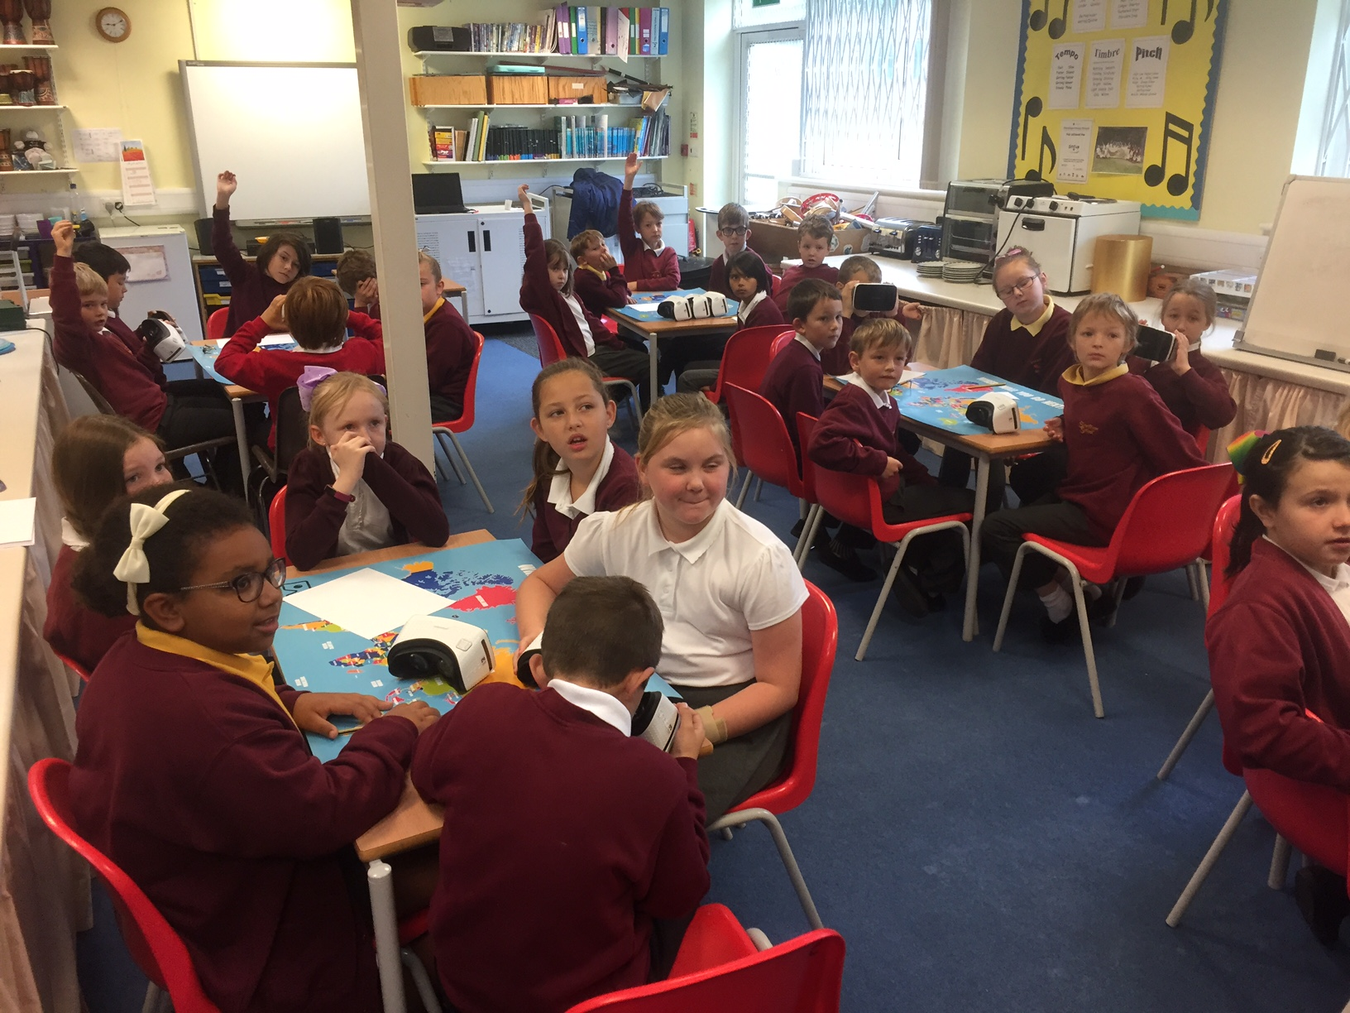
Congratulations to our new Head Boy Ronnie and Head Girl Ella. It was a very hard decision to make as there are so many wonderful children in Year 6.
Next Thursday we will be celebrating European Day in School. You will have had a letter home from your class teacher telling you which country your child will be studying. Remember to dress your child up in the colours of the country’s flag!
I am pleased to say the water situation has been rectified and we are able to use the water in Key Stage 2. Thank you for your patience.
Have a lovely weekend with your families.
Thank you,
Mr Burbank.

PAs this week were Jake and Nathan. Thank you for your help.

Please can we remind you that dogs are not permitted on school grounds.

CLASS NEWS

Year F This week we have learnt the sounds ‘s’ and ‘a’. We are carrying on with rhyming
and finding words starting with the same sound. In maths we are learning how to
form our numbers.
Year 1 In science this week we have been looking at the properties of different materials.
We are also enjoying our visits from Miss Jenna who taught us all about healthy
foods which give us long lasting energy.
Year 2 We have been writing character descriptions that include adjectives in English this
week. In maths we have been looking at a range of representations of the same
number.
Year 3 This week we have started to mummify an apple and have written instructions
about the process in English. In maths we have been partitioning numbers into
hundreds, tens and ones.
Year 4 This week we have been learning about place value in maths. In English we have begun reading the story 'Mouse, Bird, Snake, Wolf' and have been doing some drama based on it. We enjoyed our virtual reality session on Monday where we travelled down a river and a very high waterfall!
Year 5 Year 5 have had a great week. They have been investigating place value in maths and sentence structure in English.
Year 6 In maths we have been learning about place value. In English we have been
learning about colons and in PE we have been playing tag rugby and learning how
to pass the ball.

Soaring High
This week the following children have earned “Soaring High”:
Year F Kiki and Leon for being fantastic Foundation learners. They are always ready to
learn and join in with everything!
Year 1 Phoebe for great listening at all times and for setting an excellent example with
her behaviour. Eva for great confidence and always putting her hand up to
answer questions.
Year 2 Theo and Lily for always presenting their work so beautifully. It is a joy to read
and to mark. Thank you both.
Year 3 Zoe and Preston for always listening to whoever is talking and always trying their
hardest in lesson time.
Year 4 Jemma for a good start to the year and Evie for a great cold writing task.
Year 5 Riven for showing great independence in his writing! Cai for showing great
perseverance!
Year 6 Layla and Ollee for excellent determination and perseverance in their maths
work. They have been really trying hard to reach the 'deep sea dive'
challenges as much as they can.

Well done everyone!

Tidy Tiger
This week Tidy Tiger goes to Foundation for having the tidiest room. Well done!

Attendance Ted
Attendance Ted was awarded to Foundation for having the best attendance last week, they will be looking after Attendance Ted next week. Well done Foundation!

School Uniform

If you need new uniform please order online or by telephone. The website is pmgschoolwear.co.uk and the order line is 0800 4046644.
Book bags and PE bags are also available to be purchased from pmgschoolwear.

