STOCKHAM PRIMARY SCHOOL
THURSDAY NEWSLETTER

Issue No: 438 Thursday 27th April 2017
Dear Parents,
Welcome back to the summer term. Please find below some useful whole school dates for your calendar:
8th May – KS2 SATS week
17th May - KS2 theme day! (English / PSHCE focus)
22nd May – Interview day for new teacher
26th – Term ends 3.05pm
5th June – Term 6 starts
4th July – Annual reports home to parents
5th July – Sports day – KS1 am, KS2 pm
7th July– FOS summer BBQ and disco evening
11th July– School games day
19th July – Term ends at 12.10pm
Welcome to Becky Thomas who is teaching in Foundation for the rest of the school year. We are recruiting for a new full time teacher. Please spread the word to any excellent teachers out there. Interviews are taking place in school on 22nd May, closing date is the 15th May. Visits to the school are essential.
Hot chocolate with the Head! - Congratulations to the first 7 children who have been selected to join me for a catch up and warm drink at Friday break time. These children have been recognised for showing consistent positive behaviour: F: Amelia, Yr 1: Kiran, Yr 2: Holly, Yr 3: Eva, Yr 4: Esmae, Yr 5: Ella & Yr 6: Alicia. I am very much looking forward to seeing them all tomorrow.
KS1 playground improvements – We are well on our way to starting phase 1 of the playground improvements. I will put the design plan on the outside door leading to Year 1 and 2 classrooms. Please take a look. The first phase will take place in May half term –the second phase will need your fundraising help.
Thank you,
Mrs Burbank.

PAs this week were Nesha and Charlie. Thank you for your help.

May is National Walking Month!
Surveys show that a generation ago 70% of us walked to school, now it is less than half nationally. From May 15th – 19th Stockham School will be taking part in The Walk to School Campaign. The Campaign aims to reverse the decline in children’s walking so that children are energised and empowered to make walking their natural choice. Please help your child to join thousands of school children across the country celebrate the benefits of walking.
Studies have shown that walking makes children feel healthier and happier and fired up to start their learning. There are also the benefits of reducing congestion and pollution outside the school.

Walking month is for all the family too! The charity Living Streets are challenging all of us to walk for 20 minutes each day throughout May. You can, if you choose, use their online tool to rate your walk so they can build a picture of how walkable our streets are, with a view to making improvements where needed. Anyone who rates their walk will be in with a chance of winning a fab family city break. To rate your walks between 1st and 31st May please visit:
https://www.livingstreets.org.uk/what-you-can-do/campaigns/rate-your-walk

CLASS NEWS

Year F We have been learning about types of transport and creating these on the laptops.
We have learnt new tricky words and in maths we have been working on addition.
Year 1 In Year 1 we have been singing pirate songs and reciting pirate poems. We
have also begun to write some of our own. In maths we have been learning
about the difference between two numbers.
Year 2 We have started our new topic ‘Never Give Up’. In science we have been
finding out about growth and change in animals and in English we have been
working hard on spelling, punctuation and grammar.
Year 3 In Year 3 we have been writing letters to Duncan. We have also been learning
about the ÷ and x relationship and how to apply it in our maths.
Year 4 This week Year 4 have begun making their Roman chariots in D.T. We have also begun our new science topic all about living things. In English we have begun work on persuasive texts and in maths we have been learning about different types of triangles and quadrilaterals.
Year 5 In Year 5 this week, we have begun to play cricket in PE. In English we have been evaluating reports!
Year 6 This week, in English, we have begun to write up our news reports. In
maths we have been revising everything we know in preparation for SATs week.
We have also been learning about North America in topic.

Soaring High
This week the following children have earned “Soaring High”:
Year F Rafe for trying very hard when writing about how he was feeling. Owen for good
listening during PE.
Year 1 Charlie for working so hard in phonics and speech activities. You’re a star!
Angel for showing such an excellent understanding of rhyme and adjectives
during our English lessons. Well done!
Year 2 Hallie for perseverance in maths and spotting patterns to help her. Zoe for a
superb write up about her Easter holidays – even though she had been poorly!
Year 3 Kaine for some fantastic explanations in maths. Eva for an excellent independent
piece of writing.
Year 4 Lily-Mae for good use of the saw in DT this week.
Lillie P for making a great start on her Roman chariot model on her own.
Year 5 Angel L and Layla - they have both shown a great improvement in their inference
skills when reading!
Year 6 Kasey for her determined attitude and persevering with all of her work. Joel for
his amazing news report and trying his very best to include all of his writing.

Well done everyone!

On Thursday 6th April, we held our second Race for Life event. All the children from Stockham and Camel tried their very best – running a very long way to help run and raise money for the charity. Thank you to all the parents who supported the event by spectating and providing cakes for the sale at the end. We have raised £173.60 so far from the cake sale. Please could the remaining sponsorship money be returned as soon as possible. Thank you!
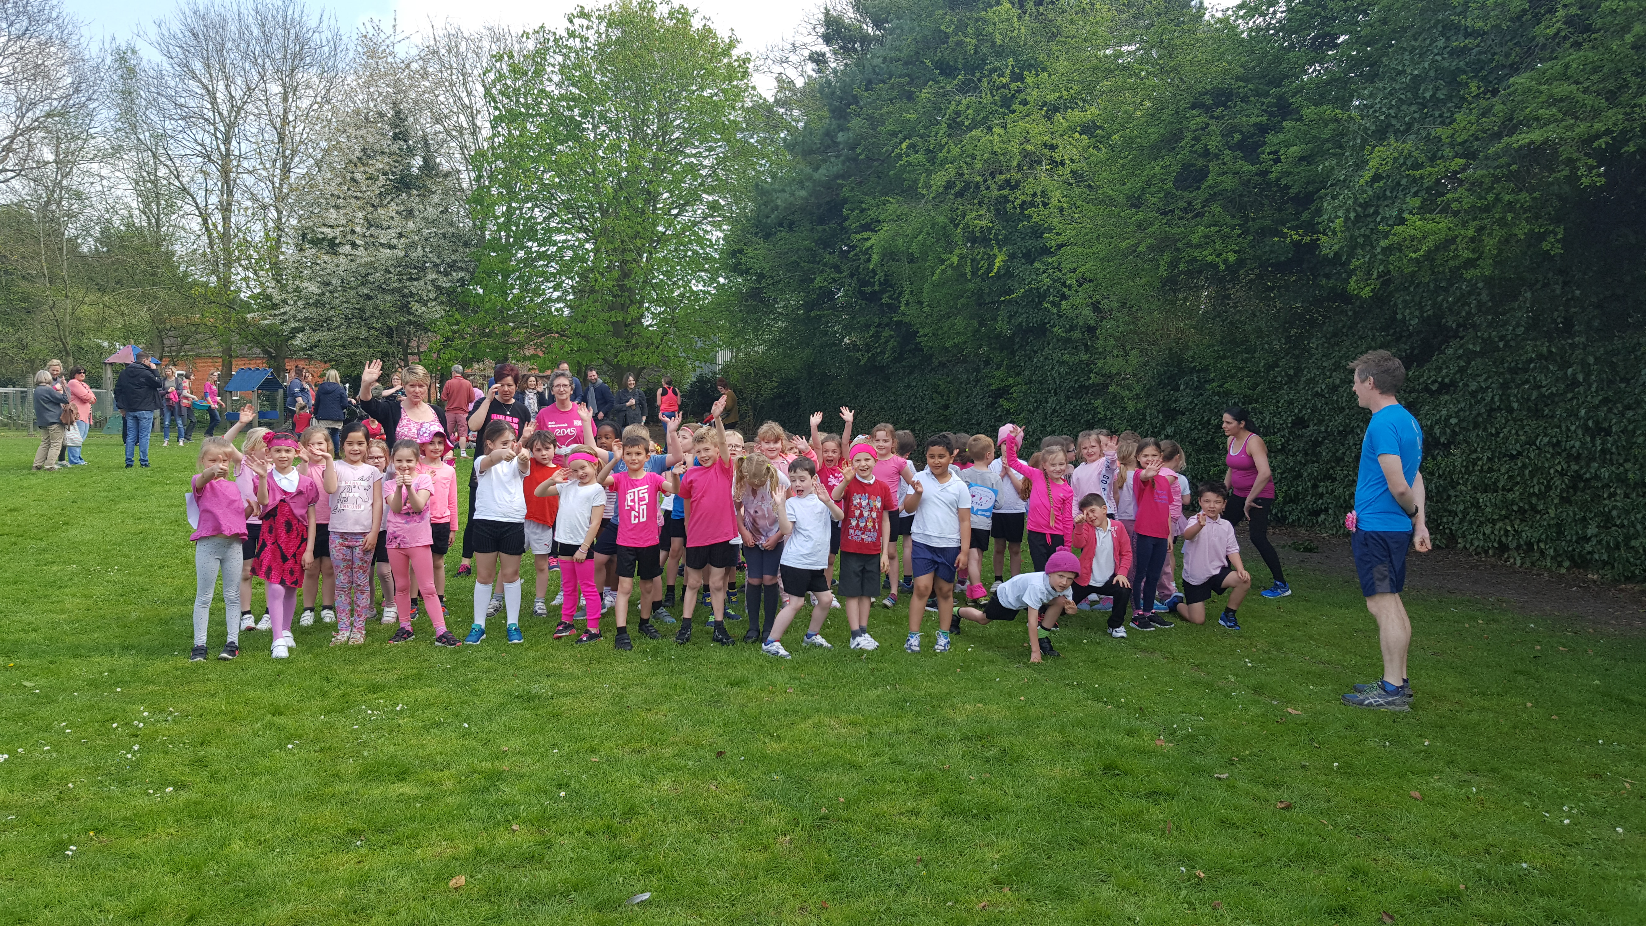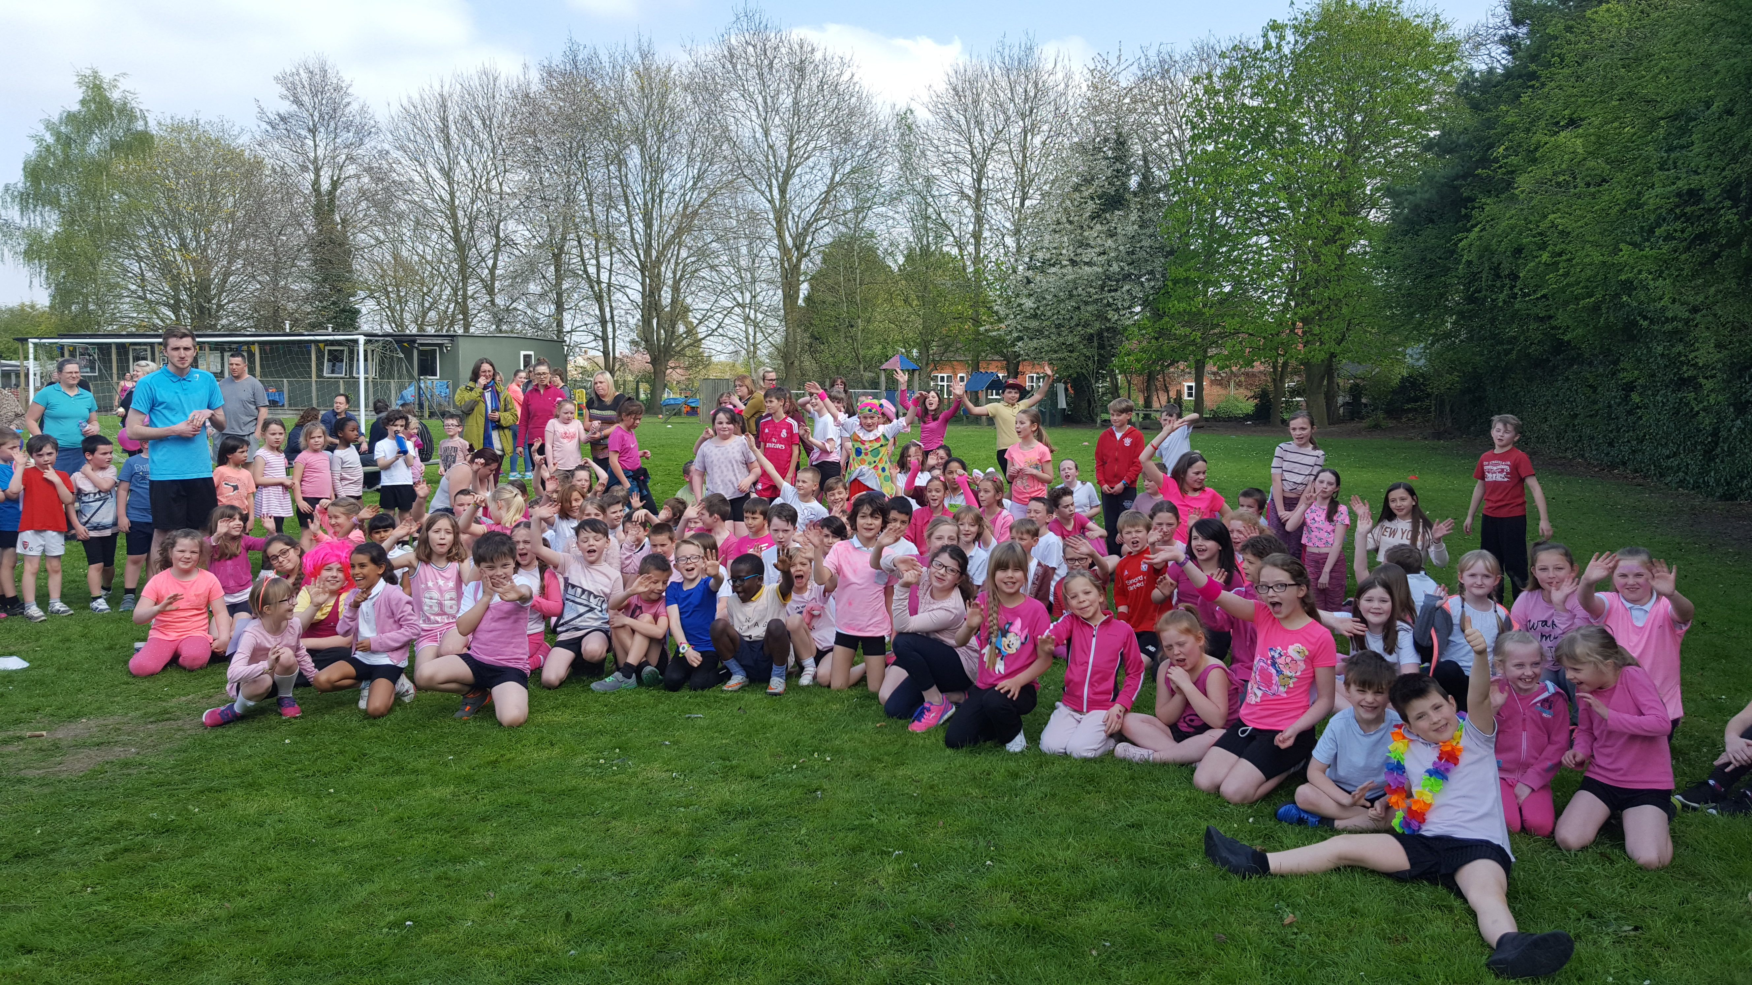

Tidy Tiger
This week Tidy Tiger goes to Year 5 for having the tidiest room. Well done!

Attendance Ted
Attendance Ted was awarded to Year 1 for having the best attendance last week, they will be looking after Attendance Ted next week. Well done 1 Year!

School Uniform
If you need new uniform please order online or by telephone. The website is pmgschoolwear.co.uk and the order line is 0800 4046644.
Book bags and PE bags are also available to be purchased from pmgschoolwear.

