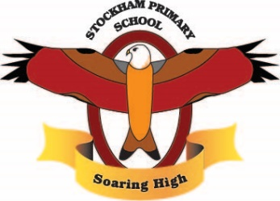
Theme:
A United Kingdom!
Term 2
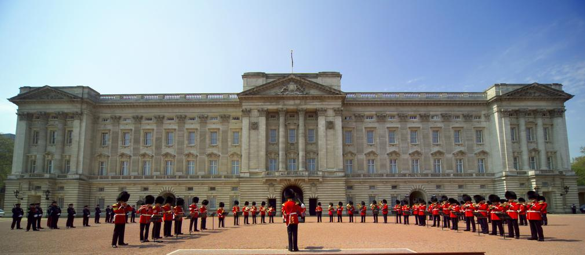

Breadth:

As writers:  Segment spoken words into phonemes, spelling many correctly.  Learn new ways of spelling phonemes for which one or more spelling can be used.  Write non chronological reports comparing and contrasting monarchs from the present day and the past (non-fiction)  Write simple instructions about how to be a royal (non-fiction).  Proof reading to check for errors in spelling and punctuation. |  | Being physically active:  Focus: Tag and target skills.  Focus: Striking and fielding skills.  Master basic movements and begin to apply these in a range of activities.  Participate in team games, developing simple tactics for attacking and defending.  Our PE days are: Tuesdays and Thursdays. | As computer Experts:  Recognise what devices can be used to take photographs.  Talk about how to take a good photograph.  Take photos in both landscape and portrait format and explain why certain photos look better in this orientation.  Experiment with different light sources.  Recognise which photos have been changed.  Identify which photos are real and which have been changed. | As scientists:  Notice that animals, including humans, have offspring which grow into adults.  Find out about and describe basic needs of animals, including humans, for survival (water, food and air).
As readers:  Apply phonic knowledge and skills as the route to decode words until automatic decoding has become embedded and reading is fluent.  Read accurately by blending the sounds in words.  Read accurately words of two or more syllables.  Listen to, discuss and express views about stories at a level beyond that at which they can read independently.  Discuss the sequence of events in stories.  Become increasingly familiar with retelling stories.  Answering and answering questions. |  | As Historians:  Place events in order on a timeline.  Learn about the lives of significant individuals in the past who have contributed to national and international achievements.  Compare and contrast different points in time using sources of evidence and understanding the idea of past and present. | Religious Education:  Why did God give Jesus to the World?  We are learning to reflect on the Christmas story and the reasons for Jesus’ birth. | As citizens (PSHCE):  Begin to understand that sometimes people make assumptions about boys and girls (stereotypes)  Understand that bullying can be about difference.  Recognise right and wrong.  Understand it is ok to be different from people and be friends with them.  Explain some ways we are different from our friends.
As design technologists:  Use a range of materials creatively to design and make products.  Use scissors to create a paper loom.  Weave strips of paper and fabric into the loom and alternate weaving the materials over and under the loom.  Explain that artists all over the world use weaving and identify one thing from another artist’s work that could be used use in a design. |  | As Mathematicians:  Addition and Subtraction  Solve problems with addition and subtraction.  Recall and use addition and subtraction facts to 20 fluently and derive and use related facts up to 100.  Add and subtract numbers using concrete objects, pictorial representations and mentally.  Show that addition can be done in any order but that subtraction cannot.  Recognise and use the inverse relationship between addition and subtraction. | As geographers:  Identify the countries of the UK and their capital cities.  Name and identify characteristics of the four countries and capital cities of the UK.  Identify the seas and oceans which surround the UK.  Use compass directions and locational language to navigate around a map. | As musicians:  Focus: Dynamics and tempo.  Talk about songs I like and how they make me feel.  Find and keep a steady beat.  Move, dance and perform actions along to music.  Copy and clap back rhythms.  Clap the rhythm of your name.  Create rhythms of long and short.  Christmas nativity.
Key Vocabulary: | Dynamics, tempo, loom, weaving, nutrition, survival, shelter, essential, oxygen, life cycle, grow, survive, independent, adult, womb, toddler, develop, foetus, stereotype, inherit, resemble, gene, reproduction, bar chart, predict, transformation, metamorphosis, amphibian, striking and fielding, compass rose, united, monarchy, emblem, legacy

Curriculum Drivers: | Curiosity: | Knowledge of the wider world: | Aspirations:
 | What is a Monarch?  What Monarchs have ruled the UK?  How do people use maps?  Has the UK always been the same for the people who live there? | What is the UK like?  What countries are part of the UK?  What are the capital cities? | Where would I like to visit in the UK?

Home learning: | Homework folders will be sent home. Please complete one piece each week for the term.  Reading or being read to as much as possible (ideally every day!) at home.

