STOCKHAM PRIMARY SCHOOL
THURSDAY NEWSLETTER

Issue No: 509 Thursday 28th March 2019
Dear Parents and Carers,
We are approaching our Easter holidays after a very busy, fun-packed term. I am looking forward to spending time with the 14 ACE (A concerted effort) children for their ACE card treat on Tuesday. Well done to all of you for a wonderful term full of hard work and consistently outstanding behaviour!
After last week’s newsletter we had some incredible donations/sponsorship collections towards the NSPCC. Thank you to both Lexi M and our overall winner, Ishani (£130!) for raising a considerable amount of money for this charity. A superb effort.
Staffing
Good news – We are pleased to inform you that Mrs Tamlin Elgar (who has been doing a wonderful job of teaching Year 4 this term) will be staying at Stockham School teaching across the school and supporting children’s progress in Key Stage 2. We are looking forward to welcoming Mrs Emma Burson as Year 4 teacher after the Easter holidays.
We wish Charlotte Wilkinson (Lunch supervisor) good luck in her new role in the kitchen and welcome back Emma Robins to the lunch supervisor team after her time off on maternity leave with baby Poppy. It is lovely to have you back!
Wednesday 3rd April – Year 1 assembly to parents 2.40pm
Thursday 4th April – Year 2 assembly to parents 2.40pm
Friday 5th April – End of term 4 at 12.10pm
Tuesday 23rd April – 8.40am - Children return to school for Term 5.

Whole school Attendance Mid-year = 97.74%
Group | Attendance | Lates
Foundation | 97.68 | 0.14
Year 1 | 97.31 | 0.04
Year 2 | 98.48 | 0.32
Year 3 | 98.06 | 0.92
Year 4 | 97.36 | 0.11
Year 5 | 97.82 | 0.21
Year 6 | 97.5 | 0.15
Boys | 98.11 | 0.35
Girls | 97.35 | 0.19
Well done to Year 2, who mid-way through the year have the best attendance so far….Boys, you are just ahead of the girls!

SCHOOL CLOSURE – On Thursday the 2nd May, the school will be used as a Polling station for local elections. Children are expected to be in school on Friday 3rd May, this must not be used as holiday and will be strictly unauthorised.
Many thanks,
Mrs. Burbank

PA’s this week were Millie and Santi. Thank you for your help.

Circus Tickets
There are some circus tickets still available, these will soon be on general release to local families outside our Stockham circle. Don’t leave it too late to get yours! Tickets are £8 per person (adult or child) for individual tickets; and we are currently offering family ticket deals as follows:
Family ticket (4 persons) - £28
Family ticket (5 persons) - £35
Family ticket (6 persons) - £42
To purchase online, go to www.pta-events.co.uk/friendsofstockham **You will need to register with the pta-events website. Fees apply for online transactions.
Tickets can also be obtained in person (cash or cheque payable to “Friends of Stockham”) via the school office.

Clothing Collection
Thank you to everyone who contributed to our clothing collection in October - you raised £246! Friends of Stockham have arranged the next clothing collection for mid-May! We will send home a collection bag with full details of the items we can take. In the meantime, please save us any unwanted but usable clothes, shoes, hats, belts, bags, bed sheets and towels. If you have any items of fancy dress (particularly Christmas nativity) or school uniform with the Soaring High Stockham logo, please bag these separately and hand them in to a member of Friends of Stockham. Further details and collection bags will be sent after the Easter holiday. Thank you for your support.

CLASS NEWS

Year F This week in literacy the children have been busy creating their own story books.
They have used the story openers to help them create a 3 sentence story. In maths
we listened to some cool Beat That music and had a go at answering as many
addition questions as we could in 30 seconds. We were amazed at how well the
children did!
Year 1 This week in maths we have been starting to look at our numbers up to 50. In
English we have been reading our story ‘Imaginary Fred’ and making our own
imaginary friends and using adjectives to describe them.
Year 2 We have really enjoyed making our magical gardens in our D & T lessons this
week. We had to think carefully about how to add our moving parts and any
amendments to our design that were required.
Year 3 This week we have started looking at tenths in maths. In science we have learnt
about fossils and the palaeontologist Mary Anning. We have also been practising
hard for our assembly.
Year 4 We have been discovering more about volcanoes in topic and English where we will
be recounting details of past volcanoes. In maths we have started on decimals.
Year 5 This week we have been looking at long multiplication in maths and in English we
have been writing spine poems about our monsters.
Year 6 This week Year 6 have been designing science electronic board games. In English
we have begun to write our spooky Alma stories. In maths we have been finding
fractions and percentages of amounts.

Soaring High
This week the following children have earned “Soaring High”:
Year F Elijah R for always thinking of others and for trying his best in writing. Eliza for
trying really hard in her learning this week, she amazed us in Phonics with her
beautiful writing.
Year 1 Joey for using fantastic confidence in English and writing an amazing description.
Bella for using her determination when grouping numbers, well done for trying
your hardest!
Year 2 Frankie for superb perseverance in both maths and D & T this week. You were
so determined to present your work well and to complete the tasks. Well done!
Jenson for showing excellent teamwork in the classroom and during break times.
You have shown such support and kindness towards your friends and
classmates.
Year 3 All of Year 3 for their fantastic class assembly! Well done. ☺
Year 4 Ethan for determination and perseverance in maths. Phoebe for moving out of
her comfort zone in art – it worked well to push yourself.
Year 5 Lucy M for showing great perseverance in maths. Rosalind for using great
independence and choosing very apt word choices.
Year 6 Jess, Minah, Shaun, Isobel and Liam for excellent team work during our story
telling lessons to compose complex sentences with lots of spooky features.

Well done everyone!

Tidy Tiger
This week Tidy Tiger goes to Year 3 for having the tidiest room. Well done!

Attendance Ted
Attendance Ted was awarded to Year 4 for having the best attendance last week, they will be looking after Attendance Ted next week. Well done!

This terms sporting news:

It's been an incredibly busy but fantastic time for sport this term:

On Wednesday 13th February, we were incredibly lucky to have a visit from a premier league umpire Graeme Scott. He led a super assembly with KS2 about respect and fair play and what it’s like to be an umpire. The children had lots of time to ask him questions. After that, we had a key stage football tournament umpired for us by Graeme which was very exciting for the children and we saw lots of the teamwork and fair play he had discussed with them!
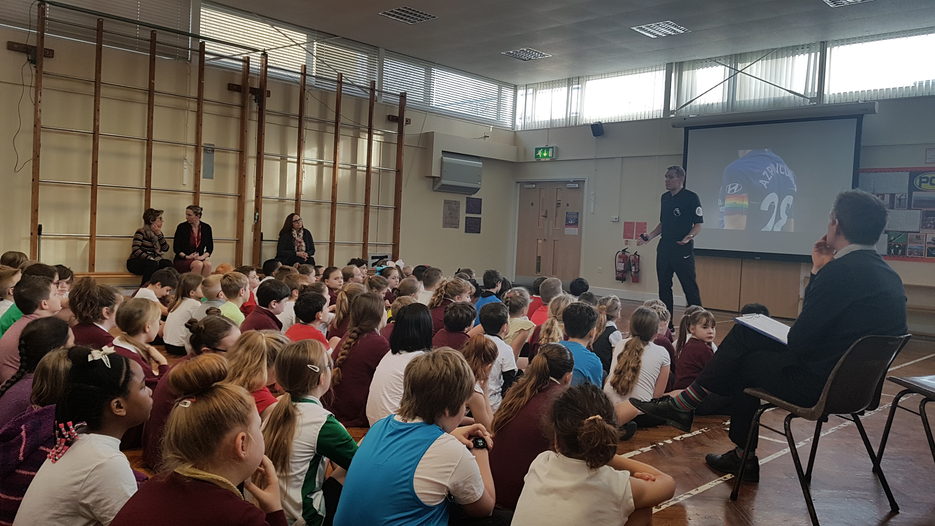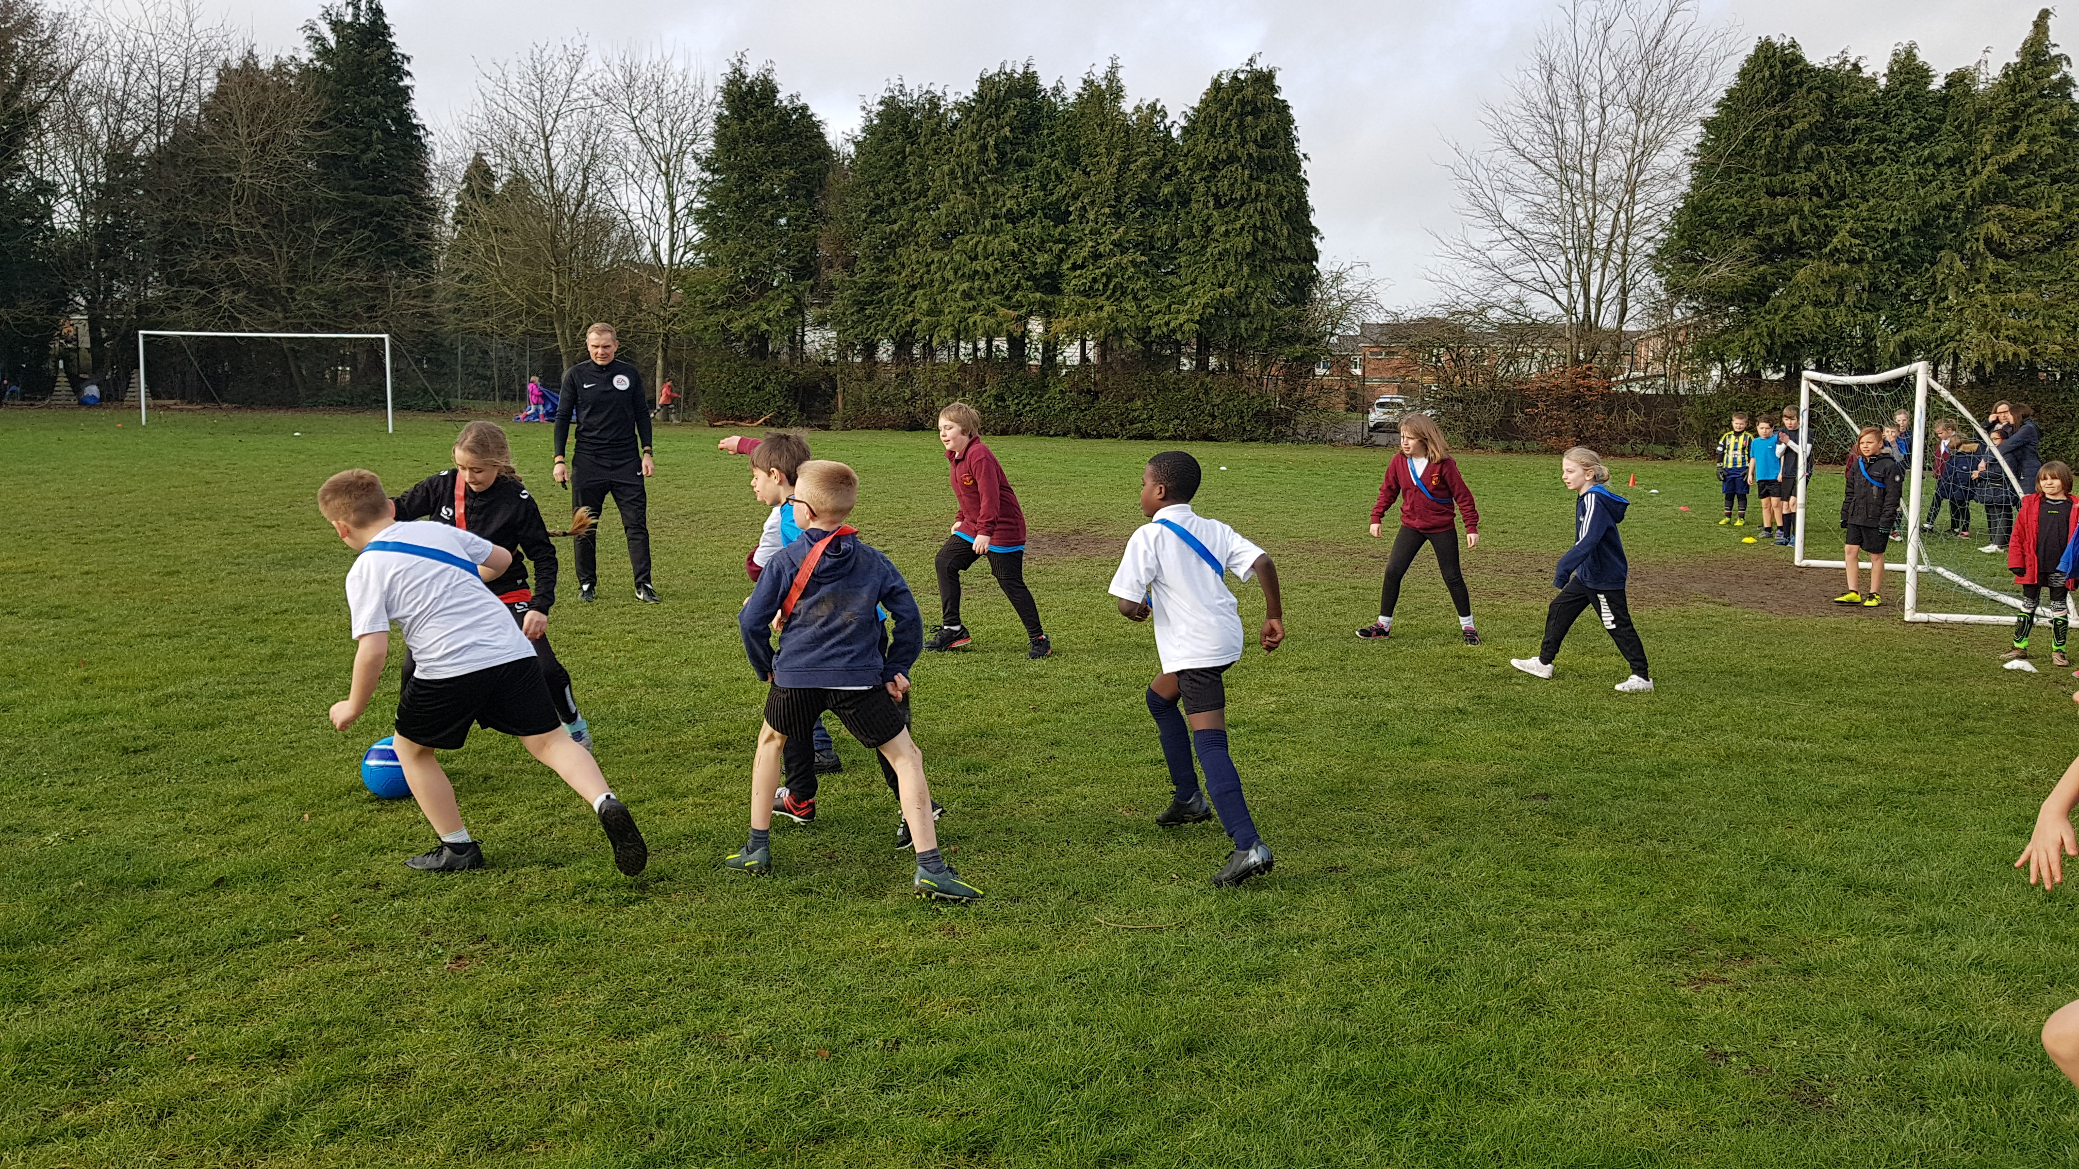

On Thursday 7th March, we took 8 lucky children to a Bisi Badminton festival at KAs. They enjoyed all the games and activities and learning some new skills and had lots of fun!


