STOCKHAM PRIMARY SCHOOL
THURSDAY NEWSLETTER

Issue No: 444 Thursday 15th June 2017
Dear Parents,
Good luck to the Year 6 children and accompanying staff who are leaving for Osmington Bay for their residential trip on Friday morning. I will add any photos and updates onto the school website under ‘news’ over the weekend. I hope the weather holds up for all the other class trips planned for next week.
Hot chocolate people: Violet Hanlon, Alfie Joyce, Libby Lowe, Isla Gregory, Isobel Alford and Joshua Wheeler. Well done – you are setting such an excellent example of how to behave and learn at Stockham School.
Information about your child’s new teacher and staffing teams will go out on the newsletter sent on Thursday 29th June ready for swap over afternoon on the 3rd July.
Thank you,
Mrs Burbank.

PAs this week were Joe and Trinity. Thank you for your help.

CLASS NEWS

Year F This week we are learning about animals that live in water and we have been
working on addition and subtraction.
Year 1 In Year 1 we have been showing Mrs Mascord how clever we are in phonics and
we have enjoyed a reading activity with her. Miss Light has been teaching us
about money in maths.
Year 2 In English we have used all 5 of our senses to describe a piece of chocolate
(especially our sense of taste!) In maths we have been looking at arrays and the
relationship between multiplication and repeated addition.
Year 3 In maths we have been looking at perimeter and its link to area. In English we
have designed our own robot animals and will be writing our own explanation
texts.
Year 4 This week we have been practising addition and subtraction strategies in maths. In science we have been learning about how some animals adapt to their habitats. We enjoyed sharing our work in our class assembly on Wednesday.
Year 5 This week in Year 5 we have been developing our sketching skills to enable us to draw Greek Mythical Creatures. In maths we have been using the bar model to help us understand decimals and fractions.
Year 6 This week in Year 6 we have been working out the number of people from different
countries that visit the Magic Kingdom in Florida in geography. We have also
been practising our lines for our leavers assembly.

Soaring High
This week the following children have earned “Soaring High”:
Year F Shona for trying so hard to learn the letter sounds. Phoebe for showing
confidence and believing in herself.
Year 1 All of Year 1 for superb phonics work this week. I am so proud of you all!
Year 2 Ava for perseverance and confidence in maths this week – well done! George for
impressing Mrs McNaught with his great knowledge and understanding about
plants.
Year 3 Faith and Lucy G for always showing great listening and teamwork skills across
the curriculum.
Year 4 Liam for improved presentation of his work. Minah for identifying her own
mistake in maths and correcting it.
Year 5 Finley, Ollee, Jake G, Jake C and Ronnie for working well as a team to fair
assess the fastest way to start a running race!
Year 6 Alec for giving very thoughtful answers in geography. Poppy for always working
well with a partner and working hard in all that she does!

Well done everyone!

Tidy Tiger
This week Tidy Tiger goes to Year 6 for having the tidiest room. Well done!

Attendance Ted
Attendance Ted was awarded to Year 2 for having the best attendance last week, they will be looking after Attendance Ted next week. Well done Year 2!

Camel Summer Fete and Raffle:
The Camel Fundraising Committee are organising an afternoon of fun and refreshments at their upcoming Summer Fete. There will be games, ice creams, cream teas, a bouncy castle and a grand raffle. The team will be selling raffle tickets after school on Wednesday 21st June.
There are some brilliant prizes available ... Miele Vacuum Cleaner, DAB radio, Luxury Hamper, Tiny Footprints Photoshoot voucher, Beauty and Fitness vouchers, a Motorlux MOT and lots and lots of tickets for family fun and days out.
Tickets are £1 each so please keep an eye out for the team to get yourself some tickets.
The draw will be at the Camel Summer Fete which will be at Stockham School on Sunday 2nd July 2-5pm.

School Uniform
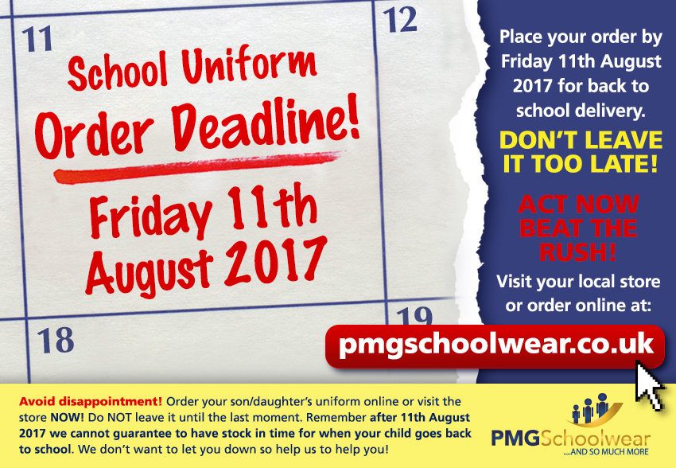
If you need new uniform please order online or by telephone. The website is pmgschoolwear.co.uk and the order line is 0800 4046644.
Book bags and PE bags are also available to be purchased from pmgschoolwear.

