STOCKHAM PRIMARY SCHOOL
THURSDAY NEWSLETTER

Issue No: 443 Thursday 08th June 2017
Dear Parents,
Welcome back. I hope you have had a lovely half term break. We kicked off our term with an incredible ‘World Beats Music’ drumming demonstration in assembly. Please find attached an information flyer for tuition with Nick.
The installation for the new Key Stage 1 play equipment is underway but at present we are in discussion with the company regarding our design requests which do not match up with the current build. Hopefully this will be resolved shortly. Our grant has been sent off; fingers crossed for a successful application. I would love to add a large sandpit with lid in the KS1 playground. If you can help build a wooden sandpit, please come and see me ☺
It is lovely to have slips returned from parents who are coming to join us for our coffee morning on the 16th June at 9am. This is part of a ‘Playful Parents Programme’. Please see Mrs Burbank or Mrs Roberts for more information.
Hot chocolate with the Head! – Well done to Jenson Parker, Fabian Stoermer, Isabella Lister, Ella Wright, Rory Smith, Jake Cox and Kulsuma Rahman.
Dates for this term:
12th June – Year 1 phonics tests
14th June – Year 4 assembly to parents 2.40pm
16th -19th – Year 6 field trip to PGL Osmington Bay
16th - Playful Parents coffee morning 9-10am
19th – Year 2 trip to The Living Rainforest
21st – Year 5 trip to The Cotswolds and sleep over, Year 2 assembly to parents 2.40pm
22nd –Year 6 music workshop with our 8 partnership schools (Springline) at Stockham School
23rd –Year 3 assembly to parents 2.40pm
27th - Dentist in school for randomly selected 5 year olds.
28th – Year 5 assembly to parents
28th/29th – Year 3 and 4 trip to Path Hill, Goring
30th – Foundation trip to Bristol Zoo.
3rd July – Children meet new teachers (swap over afternoon), new Foundation children come into school for their visit 1.30-2.45pm
4th – Reports to parents
5th – Sports day (a.m. camel race followed by Foundation and KS1, p.m. KS2)
6th – Year 6 transition day to KAs
7th – Summer disco and BBQ 6.30-8.30pm, Year 6 mosaic workshop (Day 1)
10th – Whole school tennis festival, day 2 Year 6 mosaics
11th – School games day
12th - Foundation class assembly to parents 2.40pm, day 3 Year 6 mosaics

13th – Year 1 seaside trip, leavers BBQ, SEN parent meetings
18th – Year 6 healthier lifestyle talk
19th July – leavers assembly 11am, term ends at 12.10pm.
Thank you,
Mrs Burbank.

PAs this week were Amy and Mia. Thank you for your help.

CLASS NEWS

Year F This week we are learning about the water cycle. We have written our half term
holiday news and in maths we are learning about capacity.
Year 1 We have begun our new topic ‘Beside the Seaside’ this week and we have
particularly enjoyed looking at photographs of our seaside holidays. We have been
retelling the story of the Talkative Turtle in English.
Year 2 In Year 2 we have started our new topic : CHOCOLATE! We are very excited
about this! In maths we have been looking at missing number problems and we
have been practising our sprint starts in PE in preparation for sports day!
Year 3 In Year 3 we have been writing about robots in English and in maths we have been
solving perimeter problems.
Year 4 This week Year 4 have been learning about performance poetry in English. In
maths we have been working on time and calculating time intervals. We have
begun our new geography topic 'How and why has our local area changed?' In
science we have been thinking about local habitats and what effect new play
equipment could have on our school field.
Year 5 This week in Year 5, we have begun looking in further depth at the Ancient Greeks.
In English, we have been collecting evidence against Medusa, and in topic we
have shared our current knowledge that we have of Greece now and in the past!
Year 6 This week in Year 6 we have continued typing our persuasive leaflets in English. In
maths we have been working out how much it would cost daily to run our theme
park. We have also been practicing our songs for our leavers assembly.

Soaring High
This week the following children have earned “Soaring High”:
Year F Jack for doing some fantastic work on capacity.
Violet for spending all her time in the writing area creating stories and lists.
Year 1 Hector for setting such a good example throughout the week and for working so
hard in all our lessons. Violet for showing such maturity this week and for
focusing well on independent work. Well done you two!
Year 2 Dylan and Brooke for great perseverance with some very tricky missing number
problems in maths!
Year 3 Gabriel for settling into the class. Zac and Isabelle for showing great team work
and being able to reason and explain a very tricky maths problem.
Year 4 Jaydon for showing improved work on time in maths and James for thoughtful
work in Science
Year 5 Maisie and Ronnie for showing determination to use the correct technique when
we were doing circuits in PE.
Year 6 Aleah for a determined attitude when writing her persuasive leaflet. Georgia for a
very deep thoughtful conclusion in science. Both girls deep sea dived this week.
Well done everyone!

Tidy Tiger
This week Tidy Tiger goes to Foundation for having the tidiest room. Well done!

Attendance Ted
Attendance Ted was awarded to Year 2 for having the best attendance last week, they will be looking after Attendance Ted next week. Well done Year 2!

Forest School
At Forest School last term we had been pirates, making wooden pieces of eight, mini boats, walking the plank and dying flags with natural ingredients.
After many weeks of digging and tree-root cutting we have finally buried the bath and planted seeds in it, so look out for some colourful flowers later in the summer. Well done to all those who helped to dig the hole and who carried the bath all the way across the field from the swamp garden!

Friends of Stockham
A huge thank you to everyone who brought in coins for our collection. You raised an impressive £207 (mostly in 1p & 2p) which I now have to somehow get to the bank – it’s VERY heavy!!! It took ages to count it all but my teammates, Brendan and Lucy-Jane, made it much more fun. Congratulations to our winners; Foundation, Year 2 and Year 3 who all managed to overflow their collection jars, we hope you enjoy your dvds. We’d also like to say a special thank you to Jenson in Foundation who brought in a whole ice-cream tub full of coins! In one of the jars we spotted an old style 5p from 1977 and a 1942 farthing! All the money raised will help to pay for the playground improvements so your support is much appreciated. Thank you, from Friends of Stockham.

Fathers Day
With Father's Day approaching, Friends of Stockham have organised a chance for the children to personalise a small gift for Dad or someone special who takes care of them. Gifts can be purchased any day next week (subject to availability). If your child(ren) would like to take part, please bring £1 per gift (in a named envelope) and hand it to your child’s class teacher. A representative from Year 6 will visit each class during morning registration in order for the children to obtain their gift.

Help Needed
Our school needs you! Help us win £5,000 of National Book Tokens for the school library - and get £100 for yourself! Just enter the competition online, it only takes a minute: http://po.st/schools17

Sports
On Wednesday 24th and Thursday 25th May, both Year 4 and 5/6 Quad kid competitions took place. The children did a fantastic job in the hot weather and staff members were impressed with the team work and support they showed each other during and between events. They tried really hard at all the events they did – especially the long distance races.

Well done to the Year 4 team who represented Stockham well showing determination and great sporting attitudes. Congratulations to the 5/6 team who came 6th out of 13 teams and second in the SPS partnership schools. A special mention also needs to be made for Elliot E who was the second highest scoring boy in the whole event! Well done everyone you made us really proud!

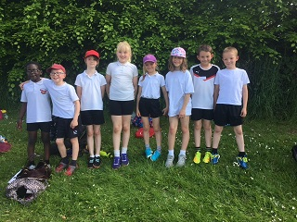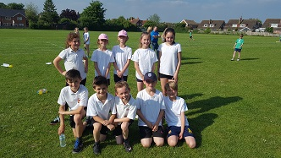

On Thursday 25th May, we held our dodge ball house colour competition. Although it was a competition, the main aim was for all children to have fun and try something new - especially the foundation children. We saw so much teamwork, confidence building and sportsmanship on the day, we were impressed with all the children.
Congratulations to the green team who were the overall winners. A huge thank you needs to go to all our Year 6 sports leaders who ran the event for everyone and looked after Key Stage one so well - you were very impressive.

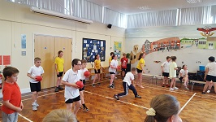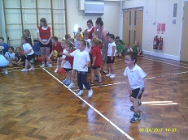

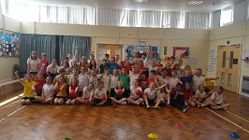

We are currently looking into investing in some new t-shirts for the partnership sporting events which take place in Key Stage 2. We take part in many events and have lots of successes - it would be great to look the part too! If you know of anyone who may be able to support us through sponsorship, any ideas would be much appreciated. Many thanks, Catherine Cargill.

School Uniform
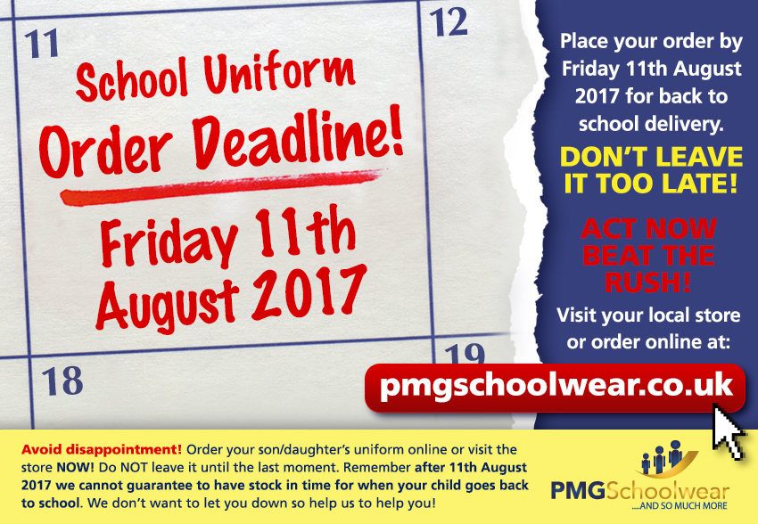
If you need new uniform please order online or by telephone. The website is pmgschoolwear.co.uk and the order line is 0800 4046644.
Book bags and PE bags are also available to be purchased from pmgschoolwear.

