STOCKHAM PRIMARY SCHOOL
THURSDAY NEWSLETTER

Issue No: 477 Thursday 17th May 2018
Dear Parents,
We are having a lovely day celebrating the Royal wedding. The children and staff are enjoying a lovely Royal picnic and have been busy learning about the Royal family. The children looked brilliant today, all dressed up in red, white and blue.
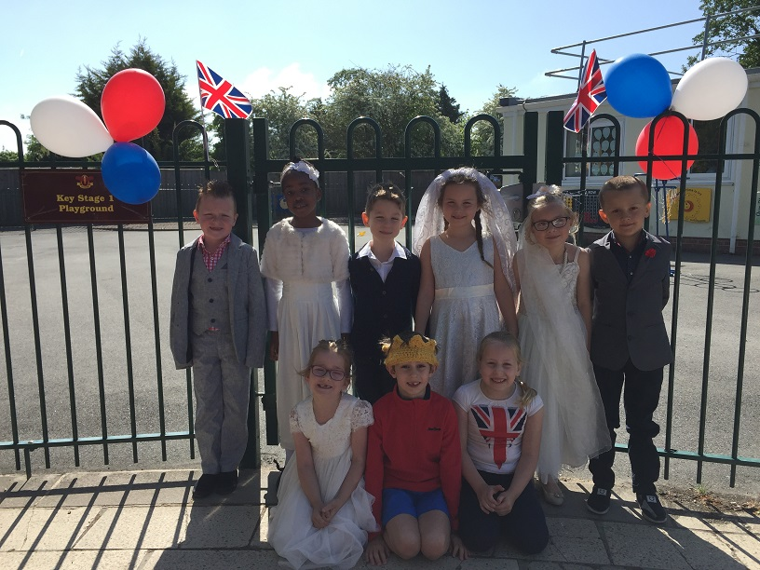
Well done to all the children in Year 6 who have worked so hard in completing their SATs this week. Mrs Cargill and the Year 6 staff are extremely proud of their achievements. Year 6 will be celebrating with their own picnic shared lunch next Thursday. It will be Year 2’s turn next week!
Staff news
Miss Lane, who teaches in Year 3, will be moving to Suffolk over the summer holidays. Miss Lane has had a very successful first year in her teaching career and will be greatly missed. We will be saying goodbye to her at the end of the school year in July. Mrs Anna Kerman is now officially a fully qualified teacher! This has taken many years of hard work and determination. We are over the moon to be welcoming Mrs Kerman onto our teaching staff team in September 2018.

All children will be invited to participate in ‘Stockham’s Got Talent 2018’. Please see the letter which will come home with your child on Monday.
End of term – Friday 25th May 3.05pm.

Many thanks,
Mrs. Burbank

PA’s this week was Joshua and Evan. Thank you for your help.

Mr. Burbank and Flo Stoermer are running 100km on 14th July along the ridgeway to raise money for Stockham School ICT equipment. If you would like to make a donation, please visit the link below to the Friends of Stockham Total Giving Page. Thank you!
https://www.totalgiving.co.uk/mypage/sssh

We would like to say a big ‘Thank You’ to Keith (the ARCH reading man) for donating a keyboard and percussion instruments to school. We are sure that the children will get great pleasure out of using and playing them.

MRC Harwell Festival Open Day
Please see attached flyer.
Here is the link to get tickets, which are free to the event but need to be registered:
https://www.har.mrc.ac.uk/research/news/20648/mrc-harwell-festival-open-day-%E2%80%93-its-all-your-genes

Well done Ella
Year 6 Ella joined The American Dance school in Grove this January and was lucky to be picked for their competition team. Ella has just competed in two dance competitions Ultimate Dance Showcase London and Starpower Manchester. Ella's team won first place in the Musical Theatre category in Manchester performing Ease On Down the Road and The Lion King.

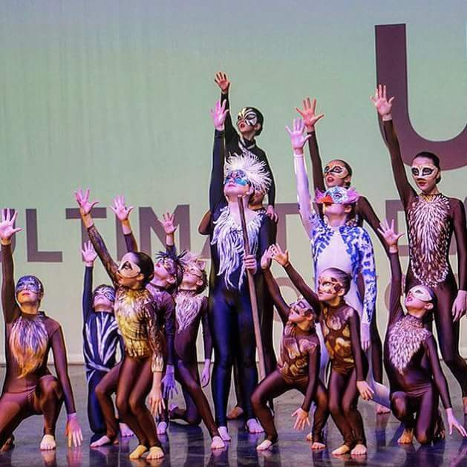

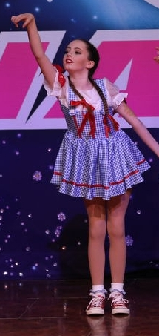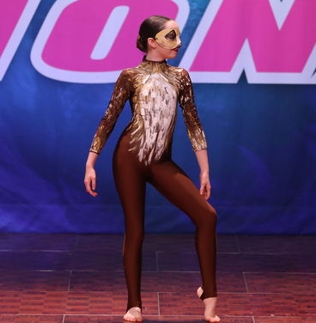

Cake Sale
There will be a cake sale in the KS1 playground next Friday, 25th May 2018 at 3pm.

CLASS NEWS

Year F This week we have loved the arrival of the tadpoles. The children have really
enjoyed drawing and writing all about them. We had lots of fun with Year 3
during our royal wedding morning. The scones were yummy!
Year 1 In Year 1 we have been writing the start of our own fairy stories ... then working
hard to improve our work. In maths we have been sorting odd & even numbers and
using the bar method to show our understanding of number bonds.
Year 2 In Year 2 we have been writing character descriptions in English. We have worked
hard to include noun phrases, powerful verbs and similes or metaphors. We have
become experts at finding fractions of numbers in maths.
Year 3 This week Year 3 have been exploring measurement. We have been learning how
to measure accurately. In English, we have been writing a short character
description based on a character we drew in charcoal!
Year 4 This week Year 4 have been planning and researching their own report, which will
be based on the Romans. In maths, we have been learning to convert between
different units of time. In P.E we worked on improving our long distance running
skills.
Year 5 Year 5 have been writing their final drafts of their non-chronological reports. We
have been adding fractions in maths.
Year 6 This week Year 6 have been doing their SATs tests! In the afternoons we have
played rounders and been creating pictures in the style of Hundertwasser.

Soaring High
This week the following children have earned “Soaring High”:
Year F All of foundation for a lovely week. The children have been praised by other
members of staff around the school for their impeccable manners and positive
attitudes.
Year 1 Peter and Frankie for great listening in phonics - you have both been working
really hard and your reading has improved greatly as a result! Well done, boys!
Year 2 Harry for showing such confidence with fractions in our maths lessons. Well
done! Ashton for taking wonderful pride in your work and showing great
perseverance with improving your presentation.
Year 3 Harriett for excellent perseverance and trying her best even when she’s feeling
unwell. Noah for showing lovely excitement about an interesting book, he had the
confidence to explain it in great detail!
Year 4 Charlotte for always contributing her ideas in lessons. Sam for showing a real
improvement with his writing.
Year 5 All of Year 5 for using their learning powers when solving tricky fraction problems.
Year 6 All of Year 6 for their amazing determination and perseverance in their SATs
tests. They have made all their teachers so proud!

Well done everyone!

Tidy Tiger
This week Tidy Tiger goes to Year 1 for having the tidiest room. Well done!

Attendance Ted
Attendance Ted was awarded to Year 3 for having the best attendance last week, they will be looking after Attendance Ted next week. Well done Year !

School Uniform
If you need new uniform please order online or by telephone. The website is pmgschoolwear.co.uk and the order line is 0800 4046644.
Book bags and PE bags are also available to be purchased from pmgschoolwear.

